OVERVIEW

ABOUT THE EVENT
Liferay Symposium brings together the brightest thought leaders within the community to share ideas, learn best practices, and make decisions in regards to multiple subjects surrounding portals, content management, collaboration, self-service portals and web experience. The Liferay community includes independent developers, Liferay staff, customers, systems integrators and technology partners.

Activities include industry case studies, formal training classes and free technology workshops as well as technology and business sessions designed to help existing and new users of the Liferay platform. Attendees of multiple roles and responsibilities will find benefits at these events including:
• new ways customers are transforming their digital strategies to create seamless customer experiences
• roadmap for Liferay and how customers are standardizing on Liferay enterprise-wide
• Liferay features, best practices, code tips & tricks and Liferay futures

THEME
Discover fresh insights into customer experience from experts who are leading the way.

Customer-centric business is here to stay. How do you address the challenges of creating a unified experience that connects every digital touchpoint? At Liferay Symposium, you'll learn how industry leaders are using a customer-first approach to transform their business. Sessions will focus on digital disruption and strategy, analytics, omnichannel technology, integration and more. Be the first to see product updates and roadmaps, connect with Liferay chiefs and senior consultants, and learn from the experiences of key clients and partners.

The agenda will be packed with hot topics around digital business, content targeting, mobile, integration, and collaboration. In addition to our exciting keynotes and product updates, attendees will also benefit from our digital marketing track, which will focus on the latest customer experience strategies:
• Tips and tactics related to the buyer's journey
• Lead scoring methodology and marketing automation
• Analytics
• Third-party integrations

AUDIENCE

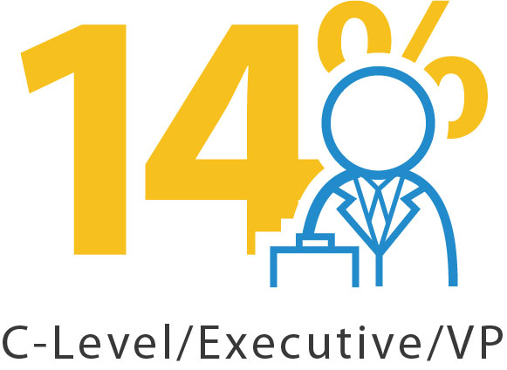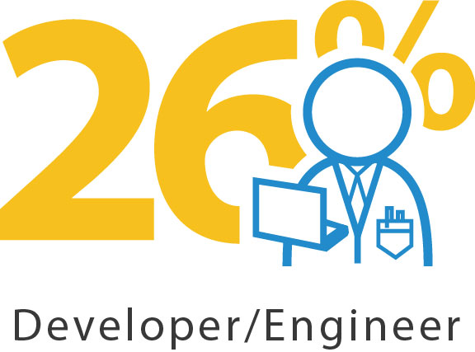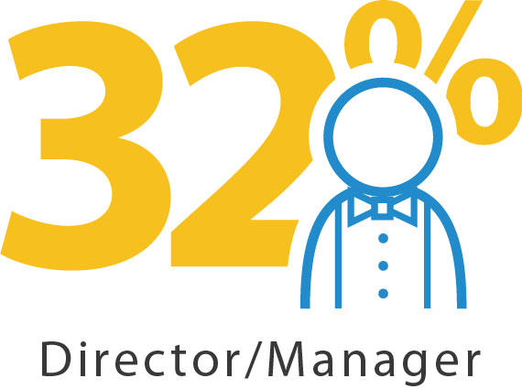

PROPOSAL

I am requesting approval to attend Liferay’s annual conference, Liferay Symposium North America. The Liferay chief executives, key engineers, strategic customers, and community leaders will leading workshops, sharing best practices, and their latest product innovations and much more. A few of the benefits are:

- Access to Liferay chiefs and executives
- Expert-led business and technical sessions
- Solutions-focused case study presentations from key customers
- Workshops and training for valuable hands-on learning and activity
- Networking and knowledge-sharing with other industry field leaders
- Optional post-symposium training immediately following the Symposium

In particular, I would like to focus on finding solutions or best practices that could benefit our current Liferay projects:
- [Add project or initiative]
- [Add project or initiative]
- [Add project or initiative]

In addition to the 60+ sessions, the conference offers endless opportunities to discuss business needs with Liferay employees as well as services partners and technology partners. I am planning to pick up new ideas to drive more productivity from our Liferay implementation and investment.

Here is an approximate breakdown of conference costs:
Airfare | $ | x.xx
Transportation (between airport and hotel) | $ | x.xx
Hotel (2 nights at $269 excluding taxes) | $ | x.xx
Meals (1 meal per day; breakfast and lunch are provided at the conference) | $ | x.xx
Registration Fee ($999 after June 30) | $ | x.xx
Total | $ | Xxxx.xx

I am currently working on ways to reduce expenses, including hotel discounts, ride sharing, and meals with vendors. I can also submit a post-conference report that will include major takeaways, tips, and a set of recommendations to maximize our Liferay investment. I am more than happy to share relevant information with key personnel throughout the company. Thank you for considering this request!

Regards,

[sign]

ROI WORKSHEET

Attendee Name
Attendee Title
Department
Conference Summary | The Liferay Symposium is the main event held annually for users, partners, and developers of Liferay technology, as well as all interested, to learn about the latest improvements and future plans for Liferay’s products and business model.  The 2016 Symposium focused on:
Website | www.liferay.com/northamerica2016

Goals Met
Identify specifically what was brought back to the organization relevant to your business goals as payback for conference investment.

1
2
3

Cost Summary

 | Budget |  | Actual
Conference Fee | $ |  | $
Airfare | $ |  | $
Transportation | $ |  | $
Hotel | $ |  | $
Meals | $ |  | $
Total | $ |  | $

Business ROI
Include contact information for all presenters, exhibitors and attendees that would be useful for your company to
contact post-event to address your business priorities.

Company
Contact Name |  | Contact Details
Description
Company
Contact Name |  | Contact Details
Description
Company
Contact Name |  | Contact Details
Description

Summary
Outline additional details on the ROI value to you and your company. Include major takeaways, new ideas, action items, and estimated impact.

